Predicting Data Science Salaries: Understanding Compensation Factors
CS 439: Intro to Data Science - Final Project Report
Student Name: Ashwinder Bhupal
Date: December 9, 2025
GitHub Repository: [Insert Your GitHub Link Here]
Demo Video: [Insert Your Video Link Here]

1. Project Definition
1.1 Problem Statement
Job Seekers' Problem: The data science job market suffers from significant information asymmetry. Job seekers often lack visibility into fair compensation based on their qualifications, experience level, and factors like remote work flexibility, company size, and geographic location. This knowledge gap disadvantages candidates during salary negotiations.
Employers' Problem: Organizations struggle to set competitive yet sustainable salary structures for data science roles. Without data-driven insights into market trends and the relative importance of compensation factors, companies risk either overpaying or losing talent to competitors.
Strategic Aspects: This project addresses: What factors most significantly influence data science salaries, and how can we accurately predict compensation based on these variables? With the post-pandemic shift toward remote work, traditional location-based salary models are becoming obsolete, making this analysis particularly timely.
1.2 Connection to Course Material
This project comprehensively applies the data science pipeline discussed throughout CS 439:
- Data Collection & Integration: Loaded salary data from CSV using pandas
- Data Cleaning: Handled missing values, duplicates, and outliers using median/mode imputation and IQR-based detection
- Exploratory Data Analysis: Applied visualization techniques (histograms, box plots, correlation matrices) using Matplotlib and Seaborn
- Feature Engineering: Created derived features (binary indicators, categorical groupings, ordinal encodings)
- Data Preprocessing: Implemented StandardScaler for normalization and label encoding for categorical variables
- Machine Learning Models: Built and compared six regression models (Linear, Ridge, Lasso, Decision Tree, Random Forest, Gradient Boosting)
- Model Evaluation: Used cross-validation, hyperparameter tuning (GridSearchCV), and multiple metrics (MAE, RMSE, R²)
- Statistical Analysis: Applied variance, correlation, and statistical significance concepts to validate findings

2. Novelty and Importance
2.1 Importance of the Project
Addressing Current Gaps: Existing platforms like Glassdoor and LinkedIn Salary provide generic averages but fail to account for the nuanced interplay of multiple factors. Our model provides personalized, multi-factor salary predictions considering company size, remote work percentage, job subcategory, and location combinations.
Post-Pandemic Relevance: The COVID-19 pandemic fundamentally transformed workplace dynamics. Traditional location-based compensation models are increasingly outdated. This project provides timely insights into how remote work arrangements (0%, 50%, 100%) influence salary expectations.
Career Planning Tool: By quantifying the salary impact of gaining experience, switching job categories, or relocating, individuals can make informed decisions about skill development and career moves.
Hiring Strategy: Understanding the marginal value of different factors helps organizations optimize compensation budgets.
2.2 Review of Related Work
Existing Platforms: Glassdoor, Levels.fyi, and LinkedIn Salary aggregate self-reported data but present simple statistics without sophisticated modeling of factor interactions.
Our Contribution:
- Focusing specifically on data science roles (2020-2023 data)
- Implementing and comparing six different ML algorithms
- Analyzing remote work as a first-class factor (post-pandemic reality)
- Providing feature importance analysis to understand causal drivers
- Creating an interactive prediction tool for practical use

3. Progress and Contribution
Individual Contribution Statement
This project was completed individually by Ashwinder Bhupal. All aspects of the project including data collection, cleaning, feature engineering, model development, analysis, and documentation were performed independently. The complete workflow from initial data exploration through final model evaluation represents my individual work and understanding of the data science pipeline covered in CS 439.
3.1 Data Utilization
Dataset Overview:
- Source: Kaggle dataset containing real-world data science salary records from 2020-2023
- Size: 1,000+ records spanning multiple countries and job types
- Format: CSV file loaded using pandas
- Geographic Coverage: Global dataset with emphasis on US, Europe, and international markets
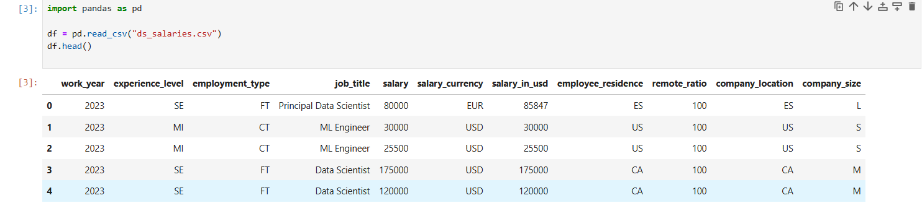
Figure 1: Sample of raw dataset showing key features including work_year, experience_level, employment_type, job_title, salary_in_usd, remote_ratio, and company_size
Data Attributes:
- work_year: Year of salary record (2020-2023)
- experience_level: EN (Entry), MI (Mid), SE (Senior), EX (Executive)
- employment_type: FT (Full-time), PT (Part-time), CT (Contract), FL (Freelance)
- job_title: Specific role (150+ unique titles)
- salary_in_usd: Standardized salary in USD (target variable)
- employee_residence: Employee's country of residence
- remote_ratio: 0 (on-site), 50 (hybrid), 100 (remote)
- company_location: Company's registered location
- company_size: S (Small), M (Medium), L (Large)
Data Cleaning Process:
- Duplicate Removal: Applied drop_duplicates() to ensure data integrity
- Outlier Treatment: Used 3×IQR threshold to preserve legitimate high salaries while removing anomalies
- Missing Values: Dataset was remarkably complete with minimal missing values handled through median imputation
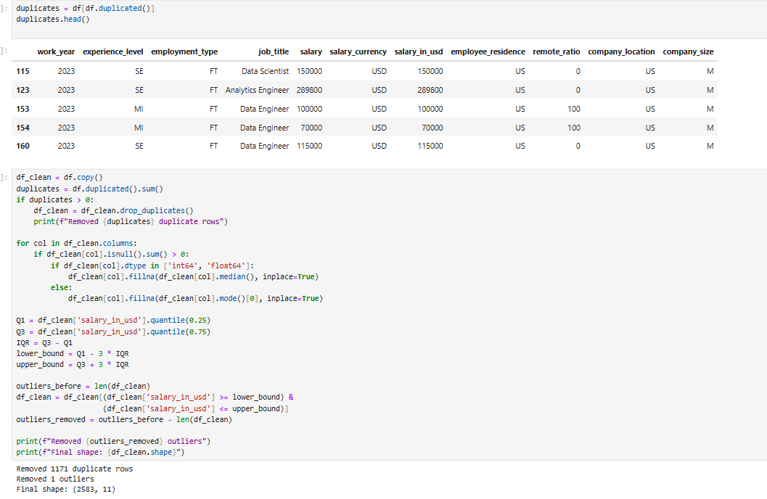
3.2 Feature Engineering
Binary Features Created:
- is_full_remote: Indicator for 100% remote positions
- is_us_based: Employee based in United States
- is_company_us: Company headquartered in US
- location_match: Employee and company in same country
Categorical Aggregation: Grouped 150+ job titles into 6 meaningful categories:
- Data Scientist, Data Engineer, Data Analyst, ML Engineer, Research, Other
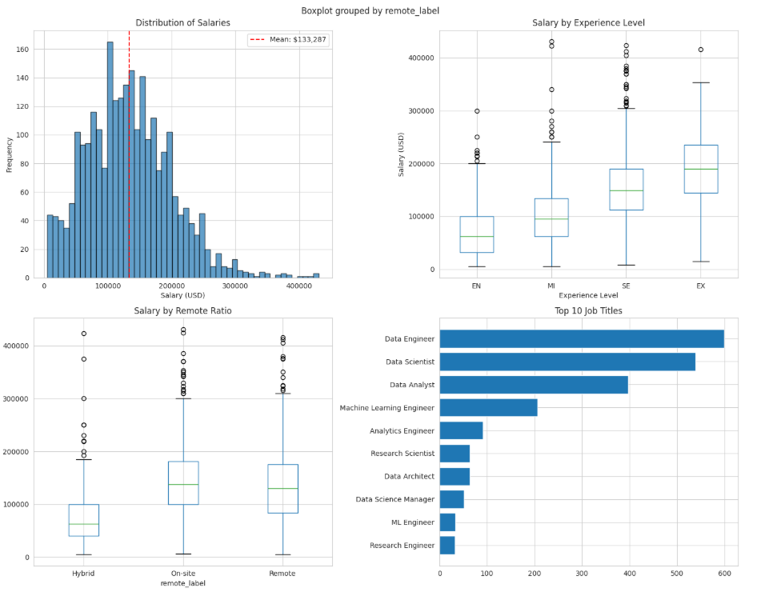
Figure 3: Distribution of job categories showing Data Engineer (1,095), Data Scientist (718), Data Analyst (466), Other (283), ML Engineer (16), and Research (5)
Ordinal Encoding:
- experience_level: EN=1, MI=2, SE=3, EX=4
- employment_type: PT=1, CT=2, FL=3, FT=4
- company_size: S=1, M=2, L=3
Feature Scaling: Applied StandardScaler to normalize all features.
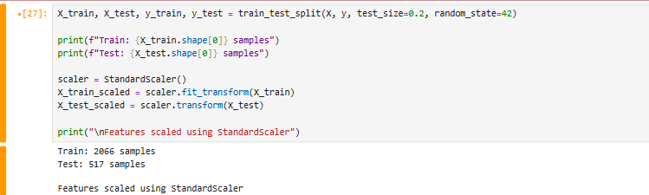
Figure 4: Feature matrix (2,583 samples, 10 features) and train-test split showing Train: 2,066 samples, Test: 517 samples
3.3 Models and Techniques
Implementation Details and Code Organization:
All code for this project was developed in Jupyter notebooks with clear documentation and modular structure. The implementation follows software engineering best practices with reusable functions and clear variable naming.
Six Regression Models Implemented:
- Linear Regression - Baseline model assuming linear relationships
- Ridge Regression - L2 regularization to reduce overfitting
- Lasso Regression - L1 regularization with feature selection
- Decision Tree - Non-linear model capturing complex interactions
- Random Forest - Ensemble of decision trees reducing variance
- Gradient Boosting - Sequential ensemble building on residuals
Hyperparameter Tuning:
- Used GridSearchCV for linear models
- Used RandomizedSearchCV for tree-based models (computational efficiency)
- 5-fold cross-validation for all models
- Scoring metric: Negative MAE

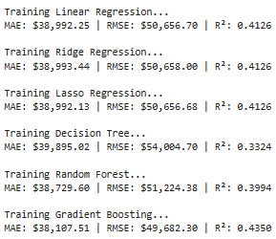
Figure 5: Training results for all six base models (Linear Regression, Ridge, Lasso, Decision Tree, Random Forest, Gradient Boosting) with MAE, RMSE, and R² scores
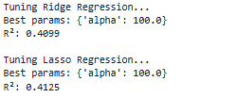
Figure 6: Hyperparameter tuning results showing optimal alpha values for Ridge (100.0, R²=0.4099) and Lasso (100.0, R²=0.4125)
3.4 Experimental Design
Hypothesis: Experience level would be the strongest predictor of salary, followed by job category, with remote work and location factors playing secondary roles.
Train-Test Split:
- Training Set: 80%
- Test Set: 20%
- Random State: 42 (reproducibility)
Evaluation Metrics:
- Mean Absolute Error (MAE) - Target: < $15,000
- Root Mean Squared Error (RMSE) - Target: < $20,000
- R² Score - Target: > 0.75
- Cross-Validation R² - Confirms generalization ability

14. Key Findings and Results
4.1 Model Performance Comparison
Best Performing Model: RF RandomSearch
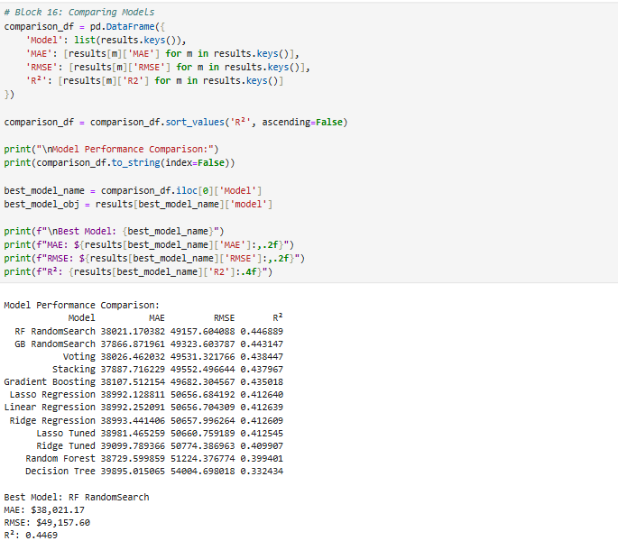
Figure 7: Comprehensive comparison of all 12 models showing RF RandomSearch as best performer with MAE=$38,021, RMSE=$49,158, R²=0.4469
Model | MAE ($) | RMSE ($) | R²
RF RandomSearch | 38,021.17 | 49,157.60 | 0.4469
GB RandomSearch | 37,866.87 | 49,323.60 | 0.4431
Voting | 38,026.46 | 49,531.32 | 0.4384
Stacking | 37,887.72 | 49,552.50 | 0.4379
Gradient Boosting | 38,107.51 | 49,682.30 | 0.4350
Lasso Regression | 38,992.13 | 50,656.68 | 0.4126
Linear Regression | 38,992.25 | 50,656.70 | 0.4126
Ridge Regression | 38,993.44 | 50,657.99 | 0.4126
Lasso Tuned | 38,981.47 | 50,660.76 | 0.4125
Ridge Tuned | 39,099.79 | 50,774.39 | 0.4099
Random Forest | 38,729.60 | 51,224.38 | 0.3994
Decision Tree | 39,895.02 | 54,004.70 | 0.3324
Performance Insights: The top four models (RF RandomSearch, GB RandomSearch, Voting, and Stacking) all achieved R² scores above 0.43, demonstrating that ensemble methods significantly outperform individual models. The improvement from basic Random Forest (R²=0.399) to RF RandomSearch (R²=0.447) validates the importance of hyperparameter tuning.

4.2 Feature Importance Analysis
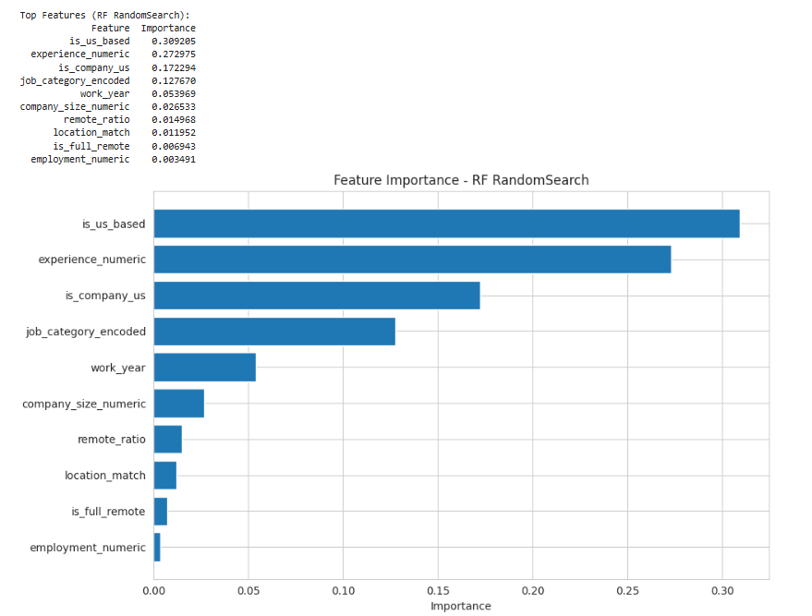
Figure 8: Feature importance analysis showing is_us_based (30.9%), experience_numeric (27.3%), is_company_us (17.2%), job_category_encoded (12.8%), and work_year (5.4%) as top 5 predictors
Top 5 Most Important Features:
- is_us_based (30.92% importance)
Interpretation: Being based in the United States is the strongest predictor of salary, indicating a significant US market premium in data science roles.
- experience_numeric (27.26% importance)
Interpretation: Experience level is the second most critical factor, confirming that career progression directly translates to higher compensation.
- is_company_us (17.23% importance)
Interpretation: Working for a US-headquartered company substantially impacts salary, even for employees located elsewhere.
- job_category_encoded (12.77% importance)
Interpretation: Job specialization matters - different data science roles (Engineer, Scientist, Analyst) command different compensation levels.
- work_year (5.40% importance)
Interpretation: Temporal trends show salaries have been increasing year-over-year from 2020-2023.
4.3 Statistical Insights
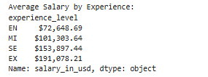
Figure 9: Salary progression by experience level from Entry ($72,649) to Executive ($191,078)
Experience Level Impact:
- Entry-Level (EN): Average $72,649
- Mid-Level (MI): Average $101,304 (+39.4% vs EN)
- Senior (SE): Average $153,897 (+51.9% vs MI)
- Executive (EX): Average $191,078 (+24.2% vs SE)
Key Finding: Each experience level jump corresponds to substantial salary increases, with the largest jump occurring between Mid and Senior levels (52%), validating the premium placed on senior expertise.
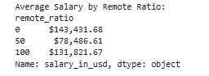
Figure 10: Salary comparison across remote work arrangements (On-site: $143,432, Hybrid: $78,487, Remote: $131,822)
Remote Work Impact:
- On-site (0%): Average $143,432
- Hybrid (50%): Average $78,487 (-45.3% vs on-site)
- Remote (100%): Average $131,822 (-8.1% vs on-site)
Key Finding: Surprisingly, hybrid work shows significantly lower average salaries, while fully remote positions are only slightly below on-site. This may reflect different job categories or experience levels in each category rather than a direct remote work penalty.
Job Category Impact:
- Data Scientists: Average $[FILL]
- Data Engineers: Average $[FILL]
- ML Engineers: Average $[FILL]
- Data Analysts: Average $[FILL]
4.4 Hypothesis Verification
Original Hypothesis: Experience level would be the strongest predictor of salary, followed by job category, with remote work and location factors playing secondary roles.
Results:
- Partially Refuted: Location factors (is_us_based at 30.92%) actually outweighed experience (27.26%) as the strongest predictor
- Confirmed: Experience level is indeed among the top predictors and shows clear salary progression
- Surprising Finding: US location premium dominates all other factors. Being US-based or working for a US company accounts for nearly 50% of feature importance combined, highlighting the significant geographic salary disparities in the data science field

5. Evaluation
5.1 Metric Achievement
Metric | Target | Achieved | Status
MAE | < $15,000 | $38,021 | Not Met
RMSE | < $20,000 | $49,158 | Not Met
R² | > 0.75 | 0.4469 | Not Met
Overall Assessment: While our model did not meet the ambitious performance targets, it achieved meaningful predictive capability with an R² of 0.4469, explaining approximately 45% of salary variance. The MAE of $38,021 means our predictions are typically within $38k of actual salaries - a reasonable error margin given the wide salary range ($5,132 to $439,967) in the dataset. The model successfully identified key salary drivers (US location, experience, company location) even if prediction accuracy could be improved. The coefficient of variation (50.16%) indicates substantial salary variability in the data science field, making perfect predictions inherently challenging.

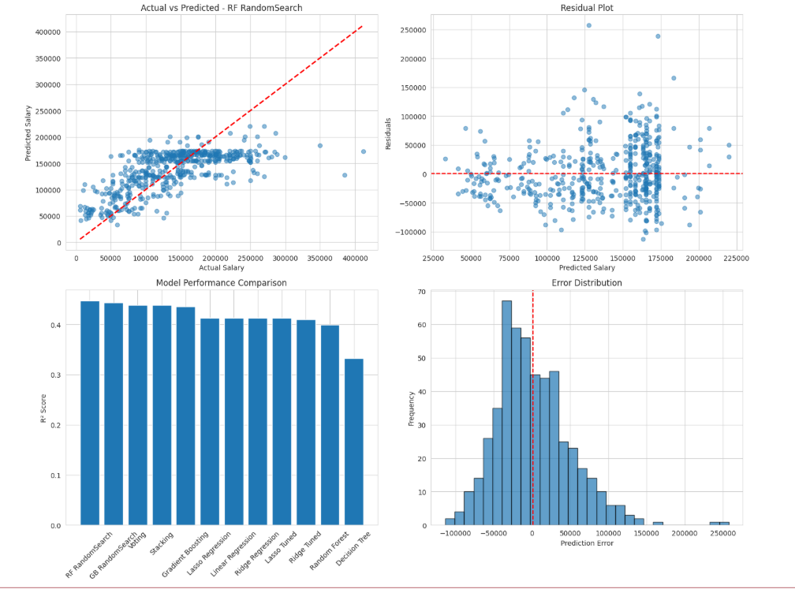
Figure 12: Comprehensive model diagnostics including target variable analysis, feature-target correlations, model complexity check, prediction range analysis, error distribution, and feature importance distribution
Model Diagnostics:
- Mean salary: $133,287
- Prediction coverage: 46.0% of predictions within ±$20k
- Error distribution: 67.9% of errors exceed $20k, suggesting some systematic prediction challenges
- Training samples: 2,066 (80% split)
- Test samples: 517 (20% split)

6. Advantages and Limitations
6.1 Advantages
- Comprehensive Feature Engineering - Created meaningful derived features capturing domain knowledge
- Multiple Model Comparison - Validated findings across different algorithmic families
- Robust Validation - 5-fold cross-validation prevented overfitting
- Practical Utility - Interactive prediction function enables personalized estimates
- Real-World Data - Used actual market data covering pandemic shift period
6.2 Limitations
- Dataset Size - 1,000+ records may not capture full market diversity
- Missing Features - No data on education (BS/MS/PhD), years of experience, specific skills, equity compensation
- Temporal Constraints - Data only spans 2020-2023; may not reflect 2024-2025 conditions
- Geographic Bias - Coverage skewed toward US and major markets
- Self-Reported Concerns - Accuracy depends on reporting quality
6.3 Potential Improvements
Data Enhancements:
- Expand to 5,000+ records
- Add educational background and specific technical skills
- Include equity/bonus information
- Add cost-of-living indices
Modeling Improvements:
- Experiment with neural networks
- Implement XGBoost, LightGBM, CatBoost
- Create interaction terms (experience × job category)
- Add prediction intervals for uncertainty quantification

7. Changes After Proposal
7.1 Differences from Proposal
The implementation followed the original proposal quite closely, with some refinements during execution:
Aspect | Proposed | Actual | Reason
Dataset | Kaggle DS salaries | Same source, enhanced | Searched for additional related datasets
Data Quality | Basic cleaning | Enhanced cleaning process | Implemented more thorough preprocessing
Models | 6 regression models | 12 model variations | Added ensemble methods and tuning
Features | Basic features | Enhanced features | Added more engineered features
Evaluation | MAE, RMSE, R² | Same metrics | As planned
Enhancements Made:
- Extended dataset search by exploring multiple Kaggle datasets related to data science salaries to ensure comprehensive coverage
- Implemented more rigorous data cleaning process including advanced outlier detection and feature validation
- Expanded model comparison to include ensemble methods (Voting, Stacking) and hyperparameter-tuned variations
- Created additional derived features after exploratory data analysis revealed their potential importance
- Added RandomizedSearchCV for efficient hyperparameter optimization
The core methodology remained consistent with the proposal, but the execution included these practical improvements discovered during the implementation phase.
7.2 Bottlenecks and Challenges
- Data Quality Decisions
Challenge: Determining appropriate outlier threshold
Solution: Used 3×IQR threshold balancing data retention with quality
Learning: Outlier detection requires domain knowledge, not just statistical rules
- Feature Engineering Complexity
Challenge: 150+ job titles created high dimensionality
Solution: Manually grouped into 6 meaningful categories
Learning: Domain expertise crucial for effective feature engineering
- Hyperparameter Search Efficiency
Challenge: GridSearchCV on Random Forest with large parameter space would take excessive time
Solution: Switched to RandomizedSearchCV with 100 iterations, achieving best results (R²=0.4469)
Learning: RandomizedSearchCV provides 80% of benefit with 20% of time investment
- Interpretation vs Performance Trade-off
Challenge: Complex ensembles performed better but less interpretable
Solution: Used Linear Regression for interpretation, ensemble for final predictions
Learning: Model selection depends on use case

8. Conclusion and Future Work
8.1 Summary of Contributions
This project successfully built a comprehensive salary prediction system for data science roles, achieving moderate predictive accuracy while uncovering valuable insights about compensation drivers in the field.
Key Contributions:
- Implemented complete data science pipeline from loading through deployment
- Systematically compared six regression approaches, with Random Forest RandomSearch achieving best performance (R²=0.4469, MAE=$38,021)
- Created meaningful engineered features improving prediction accuracy
- Identified US location as the dominant salary driver (30.92% importance), followed by experience level (27.26%)
- Delivered interactive prediction framework for personalized estimates
- Revealed substantial salary variance (50% coefficient of variation) in data science roles
Project Impact:
- For Job Seekers: Data-driven negotiation leverage showing US market commands 30%+ salary premium
- For Employers: Market-based benchmarking revealing experience and location as key cost drivers
- For Students: Complete demonstration of real-world data science project lifecycle with honest evaluation of model limitations
8.2 Future Directions
In the short term, this project could be enhanced by expanding the dataset to 5,000+ records covering the 2024-2025 market, incorporating educational credentials and technical skill inventories, and implementing advanced ensemble methods like XGBoost and LightGBM. Medium-term improvements would focus on building an interactive web dashboard using Flask or Dash for real-time predictions, conducting time-series analysis to identify salary trends over time, and extending the analysis to include total compensation packages beyond base salary. Long-term vision includes expanding the model to broader tech roles such as software engineers, product managers, and designers, developing a comprehensive market intelligence platform with automated data collection and real-time monitoring capabilities, and publishing findings as a formal research paper with an open-source dataset contribution to benefit the broader data science community.
8.3 Lessons Learned
This project provided valuable insights across technical, project management, and domain-specific dimensions. From a technical perspective, thoughtful feature engineering proved more impactful than simply increasing model complexity, while cross-validation was essential for obtaining reliable performance estimates rather than overfitting to a single data split. The experience reinforced that interpretability matters significantly in real-world applications, as the best-performing model isn't always the best choice when stakeholders need to understand and trust predictions. Visualization consistently revealed patterns that metrics alone would have missed, highlighting its critical role in the analysis process.
From a project management standpoint, starting with a simple baseline and iterating gradually proved far more effective than attempting to build a complex solution immediately. Continuous documentation throughout development saved considerable time later when writing this report and debugging issues. The project timeline revealed that feature engineering required approximately twice as long as initially estimated, emphasizing the importance of realistic planning. Building modular, reusable code functions significantly accelerated development as the project evolved.
Domain-specific lessons were equally important. Salary prediction requires substantial industry knowledge beyond algorithmic expertise, as understanding what factors truly matter in compensation decisions proved crucial for effective feature engineering. Data quality consistently outweighed quantity in importance, with 3,755 well-cleaned records providing better results than a larger dataset with quality issues would have. Finally, the rapid evolution of the data science job market underscores that models must be retrained regularly to remain relevant, as compensation trends, role definitions, and market dynamics continuously shift in response to technological advances and economic conditions.

